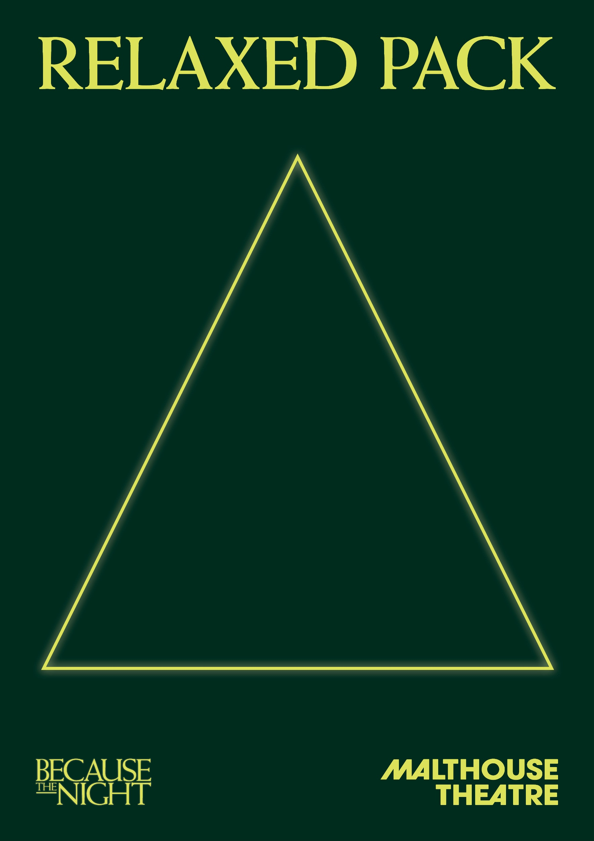
GENERAL INFORMATION

Because The Night
An immersive theatre adventure by Malthouse Theatre

Dates: 23 March – 26 September 2021

Venue: The Malthouse, 113 Sturt Street, Southbank VIC 3006

Company Website: https://www.malthousetheatre.com.au/

Because The Night Access Information: https://www.malthousetheatre.com.au/because-the-night-access/

PERFORMANCE STYLE

Because The Night is an immersive theatre show. This means that the performance is experienced by moving through the world of Elsinore as the story plays out around you. The actors will not touch or talk to you, and you will be asked to not touch or speak to other audience members or performers during the show.

When you book a ticket, you can choose one of the entrances to start the show in:
- The Bedroom: this entrance is accessible by wheelchair.
- The Gymnasium: this entrance is accessible by wheelchair.
- The Royal Office: this entrance requires you to use two flights of stairs to get to the room. This entrance is not accessible by wheelchair.

There is no right or wrong way to experience Because The Night. During the show, you can follow the characters as their stories unfold, or explore the set and discover the secrets and mysteries of the town.

CONTENT INFORMATION

The performance contains some strong sound and lighting effects, haze, coarse language and adult content. A full list of content warnings are included in this document on pages 10 and 11.

HOW TO BOOK / CONTACT US

Information about The Malthouse venue and Because The Night can be found on Malthouse Theatre’s website www.malthousetheatre.com.au

You can book tickets on the website or by calling the Box Office on (03) 9685 5111.

If you have any questions about information in this document, you can contact Annie Bourke by emailing abourke@malthousetheatre.com.au or calling (03) 9685 5150.

We have done our best to incorporate the needs of a range of audiences throughout the process of creating Because The Night. We are committed to continual improvement and learning and welcome your feedback.

HOW TO USE THIS RELAXED PACK

This is a preshow resource that has been designed by Malthouse Theatre in consultation with A_tistic Theatre to support your experience of Because The Night.

There will not be a dedicated Relaxed Performance for this production. Instead, this Relaxed Pack aims to support your attendance at any of the performances without a dedicated guide.

This document is intended to help you prepare to attend the performance. While we have tried to be as accurate and comprehensive as possible, due to the nature of live performance there may be moments that are different on the night.

The information in this guide is for anyone who wants extra information about the audience experience and what to expect in the performance.

When putting the information together, we have considered a range of abilities and needs. This may include but is not limited to people with autism, sensory sensitivities, learning disabilities, dementia as well as those living with anxiety or who have experienced trauma.

HOW TO GET TO THE MALTHOUSE

The Malthouse is located at 113 Sturt Street in Southbank. You can get here by tram, train, bike or car.

Tram: The closest tram stop is Stop 18 – Grant Street/Sturt Street (Route 1). You can also get to the venue from St Kilda Road. Get off at Stop 17 – Grant Street, Police Memorial/St Kilda Road. From this stop, it is a 6-minute walk to the venue via Grant Street.

Train: Flinders Street station is approximately 15-minute walk away.

Bike: There are bike racks and a Melbourne Bike Share station outside The Malthouse.

Car: There is limited on-street parking on Grant Street, Sturt Street and Dodds Street. There are 2 disabled spaces outside The Malthouse entrance on Sturt Street.

The closest secure carparks are:
- Arts Centre Melbourne Car Park (enter from Sturt Street)
- The Australian Ballet Centre Car Park (2 Kavanagh Street)

VENUE IMAGES

Entrance from Sturt Street side
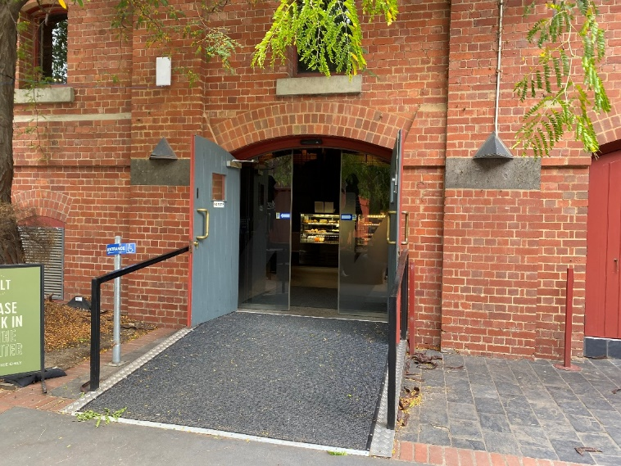

Entrance from Dodds Street side (wheelchair access)
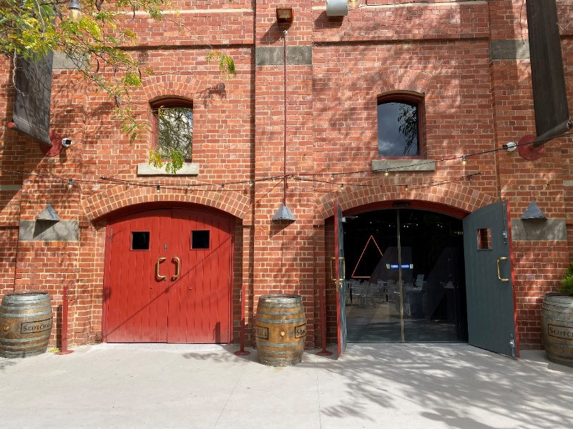

Sanitiser station and QR code to check-in at the Foyer

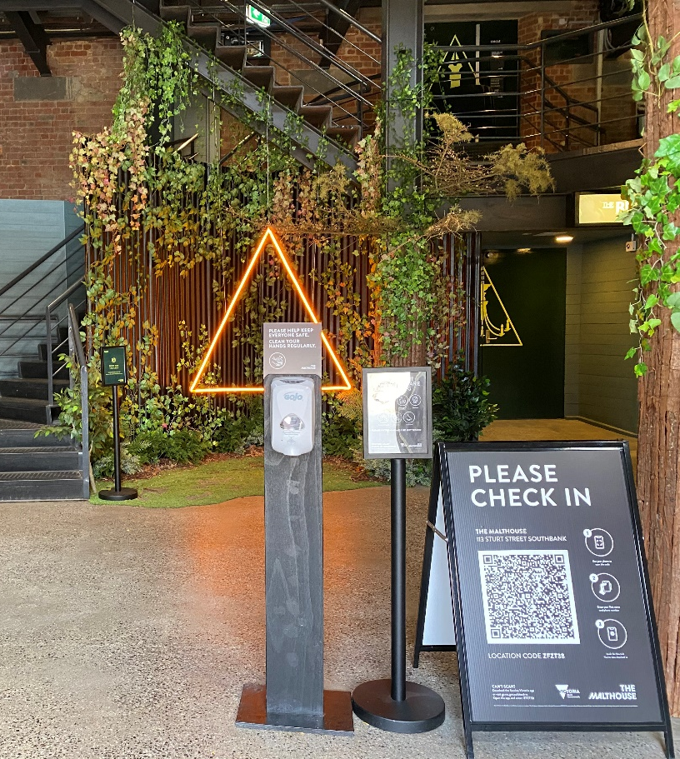

Bar and seating in the Foyer
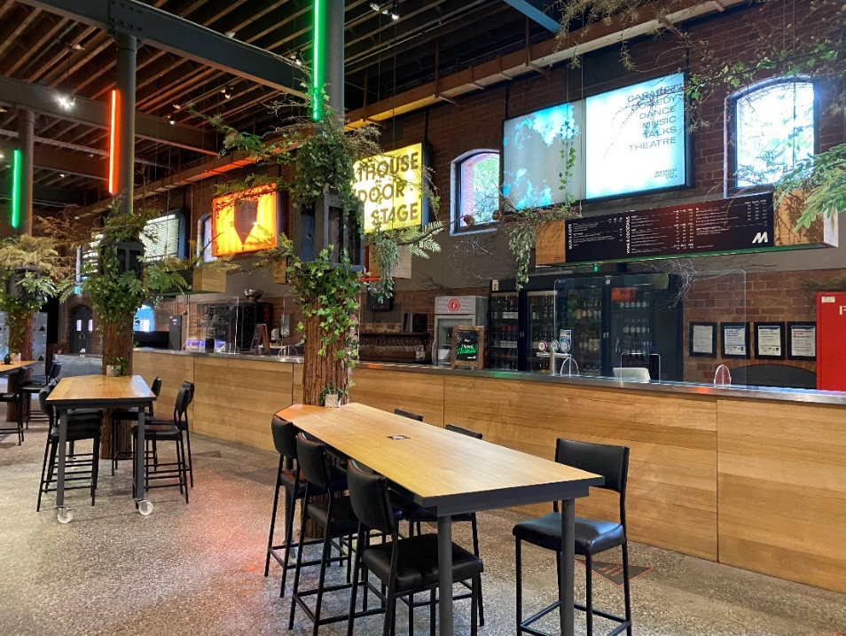

Box Office in the Foyer

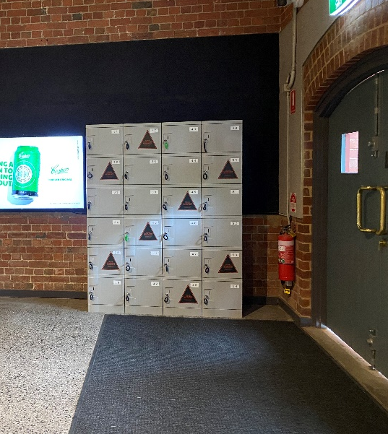
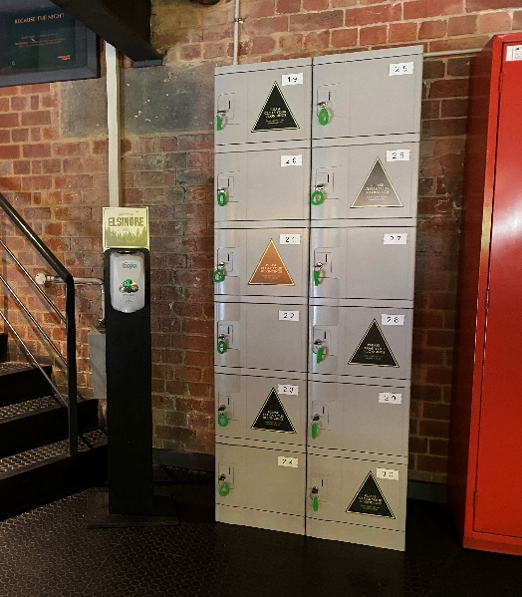
Lockers in the Foyer Lockers on Level 1

The Bedroom entrance.

This entrance is wheelchair accessible.

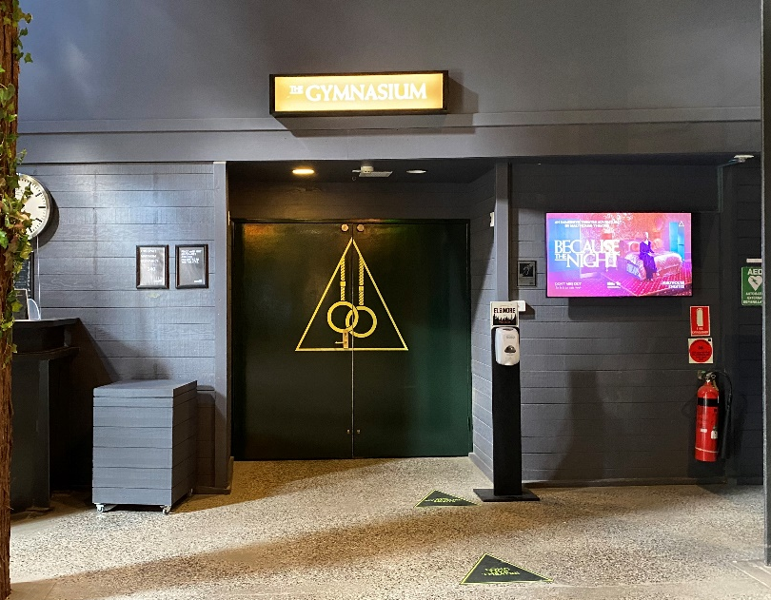
The Gymnasium entrance.

This entrance is wheelchair accessible.

The Royal Office entrance.

This entrance is not wheelchair accessible and you will need to use two flights of stairs to access the room.

RULES OF ENTRY TO THE PERFORMANCE

- No touching other audience members or performers during the show.

- In general, no large bags are allowed into the theatre, and we ask you to store these in one of our lockers. If you need to take a bag into the theatre, this is OK – just let one of the ushers at the entrance know.

NOTE: You will need a $1 coin to use the lockers. You can get one from the bar if you don’t have one with you.

- The use of phones and photography is not allowed during the performance. If you need to take your phone into the performance, this is OK – just let one of the ushers at the entrance know.

- You will be asked to wear a mask (covering the top half of your face) and black cloak to enter the performance. These items will be managed in a COVID-Safe way and will be given to you when you arrive to the performance and are collected at the end of the show when you exit. If you do not feel comfortable wearing a mask or cloak, that is OK – just tell one of the ushers at the entrance.

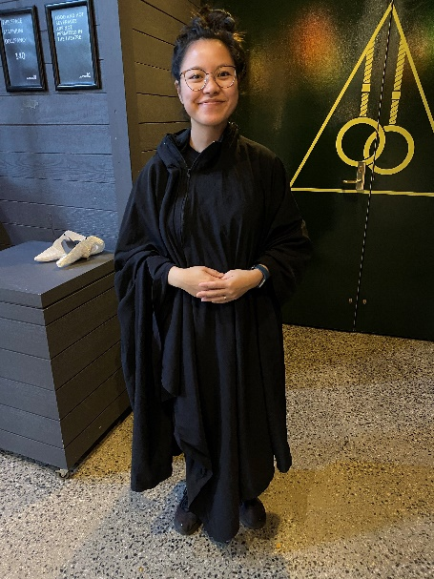
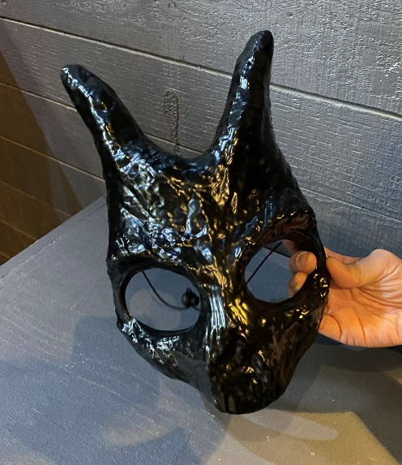
Front of the mask Back of the mask Black cloak

THE ACTORS

Because The Night has two different casts and depending on which performance you attend, you may see different actors.

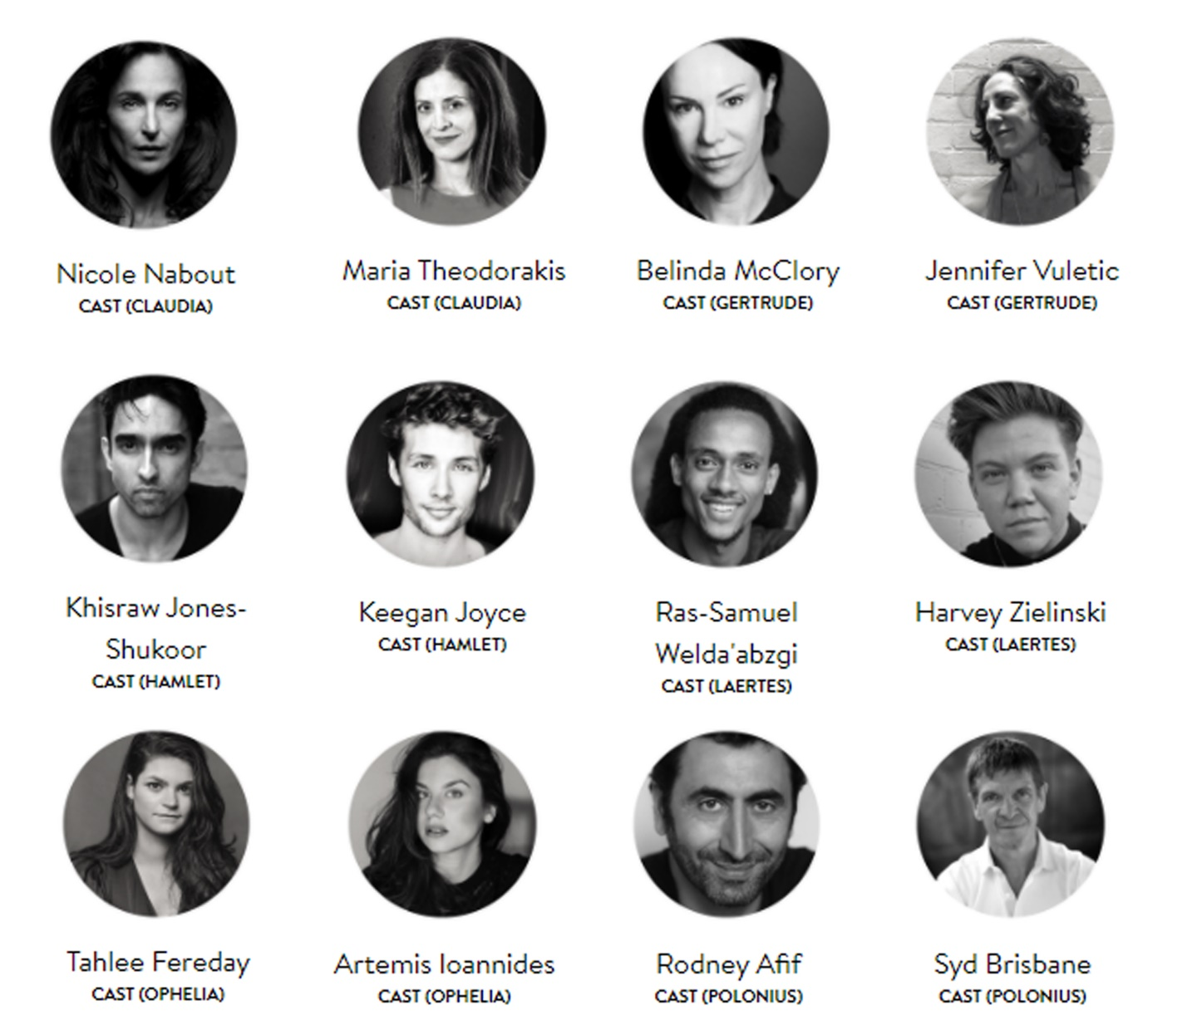

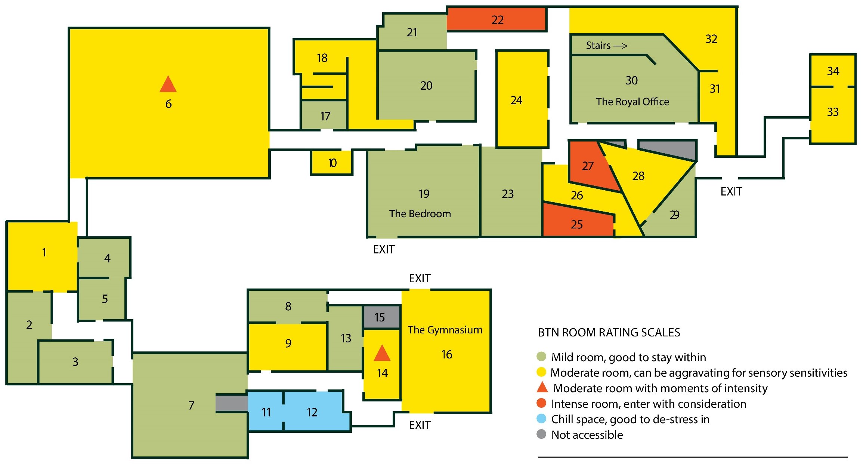
FLOOR PLAN AND ROOM RATINGS

INFORMATION ROOMS

- Gaming Arcade (Yellow)
- Constant sounds, flashing lights

- Brothel (Green)

- Ophelia’s Room (Green)

- Tree Reclaiming Room (Green)

- Elsinore’s Future (Green)

- The Mill (Yellow/Red)
- The floor is covered in tanbark (there is a path for wheelchair access)
- The end of the performance occurs in this space. It involves very loud thunder sounds, flashing lights, and sudden drops to blackness. Let ushers know if you wish to be outside of the room when the finale starts.

- Playground (Green)

- Prayer Room (Green)

- Big Pig Festivities (Yellow)
- Music plays when you enter the room, there is little space to move, and no space to sit down and rest.

- Pig Memorabilia (Yellow)
- This is a small, enclosed space, with bright lights and lots of glass reflections.

- Snow Room (Blue)

- Hamlet’s Childhood (Blue)

- Welcome to Elsinore (Green)

- Death Room (Yellow/Red)
- Light from the Gymnasium bleeds into this room and it involves extended periods of intense monochrome lighting and pulsing bass. A murder takes place in this room approximately 50-minutes into the performance.

- Glass Division (Not Accessible)

- The Gymnasium (Yellow)
- Involves extended period of intense monochrome lighting and pulsing bass. A murder takes place in this room about 50-minutes into the performance.

- Store Room (Green)

- Bunker (Yellow)
- This space is constantly cold and bleak, with very little space to sit down.
- Flickering lights.

- The Bedroom (Green)

- Painting Room (Green)

- Spying Room (Green)

- Tree Tapping Room (Red)
- Entering this room triggers a sound effect of a tree falling. It is very loud and surrounding. Enter with this in mind.

- King’s Grave (Green)

- Security Room (Yellow)
- This room has constant surveillance sounds playing, and frequently has Video being played, rewound, and moved around within it

- Inkblot Room (Red)
- This room contains a constantly strobing video feed of a Rorschach test, with non-musical unpleasant noise accompanying it

- Concealing Room (Yellow)
- This is a narrow space with very little room to sit

- Bloodshed Room (Red)
- This room contains a pile of gore, skeletons, and blood, heaped into a corner

- Triangular Forest (Yellow)
- This is a consistently lit space with no room that has no space to sit, and

- Library (Green)

- The Royal Office (Green)

- Costume Shop (Yellow)
- This is a softly lit room, but it contains costumes of many varieties of material, and masks of wild animals, clowns, dolls, and other unsettling creatures.

32. White Forest (Yellow)
- This space in lit intensely with blue light, is full of fake trees with milky spiky fronds, and has a low pitched buzzing sound always playing

33. Crosscutters Bar (Yellow)
- This space is lit like a bar and has a sound of a bar. It remains at a certain level of sound intensity, but there is plenty of space to sit down

34. Crosscutters Bar – Backroom (Yellow)
- This is the back space of the bar, with similar lighting and presentation of Sound

LIST OF CONTENT WARNINGS

Adult Themes: This play is a tragedy, and includes discussion of murder, suicide, and the death of a parent.

Coarse Language: Characters use the F-word a few times during the show, but not gratuitously.

Bright Lights: Flashes of bright light are used briefly in some sections of the show.

Loud Sounds: There are some brief loud sounds used in various scenes of the show. Ear plugs are available on request before the show, but not required.

Mild Haze: We use a low level of haze in one room of the show (The Mill).

Stage Violence: There is one sequence of intense knife violence, though no blood effects.

Stage Firearm: Three actors handle a small fake handgun. The gun is neither loaded nor fired, nor pointed directly at the audience. The gun is continually supervised, and never handled by audience members.

LEAVING THE PERFORMANCE / QUIET SPACES

If you need to leave the theatre during the show or require any assistance you can approach one of the ushers in the show. Ushers will be wearing black clothes (no cloak) and a white mask like this:
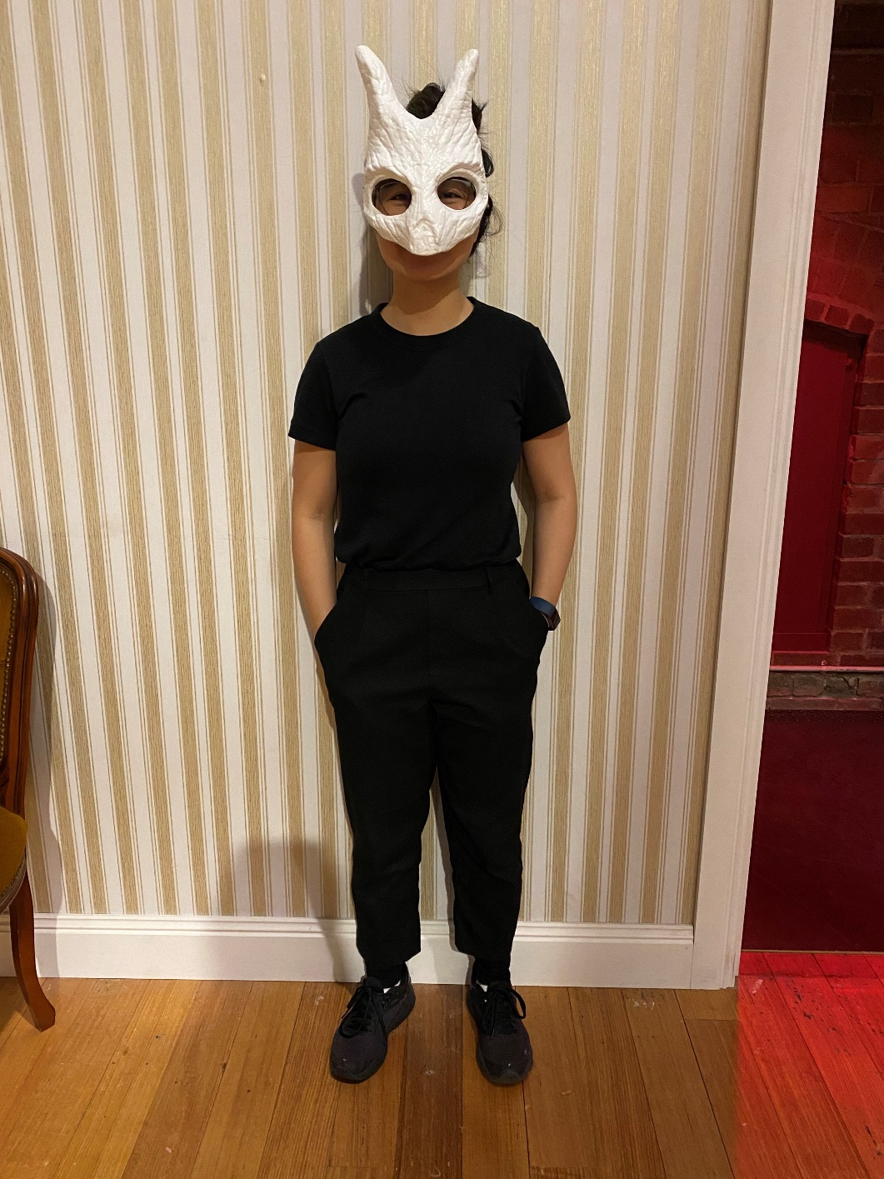

There are two quiet areas inside the performance (marked in blue on the floorplan above). Outside of the performance space, there is seating in the MALT Café, the bar area and outside in The Malthouse courtyard.

You are welcome to re-enter the performance at any time, up until the last scene (the final 15-minutes of the performance).

COVID-19 SAFETY

Because The Night is performed to 60 audience members at a time. The spaces in the performance are designed for audience members to maintain social distancing and are thoroughly cleaned between performances in line with our COVID-19 venue safety protocols. You cannot touch the actors or other audience members, and the actors will not touch you.

